Garrett Hurd
ECEN 3730
Board 3 Report
Introduction:
The purpose of Board 3 is to design, build and boot load my own Arduino Board using the ATmega328, called a Golden Arduino and compare it to a commercial Arduino board. To see which board is better, I will be analyzing the switching noise on a commercial Arduino Board using a switching noise shield and comparing the switching nose on my Golden Arduino by doing the same analysis.
Before we get into the analysis, I want to show my design process for my Golden Arduino. Below is my block diagram and the schematic for my Golden Arduino, I used resources online as an outline for this design.
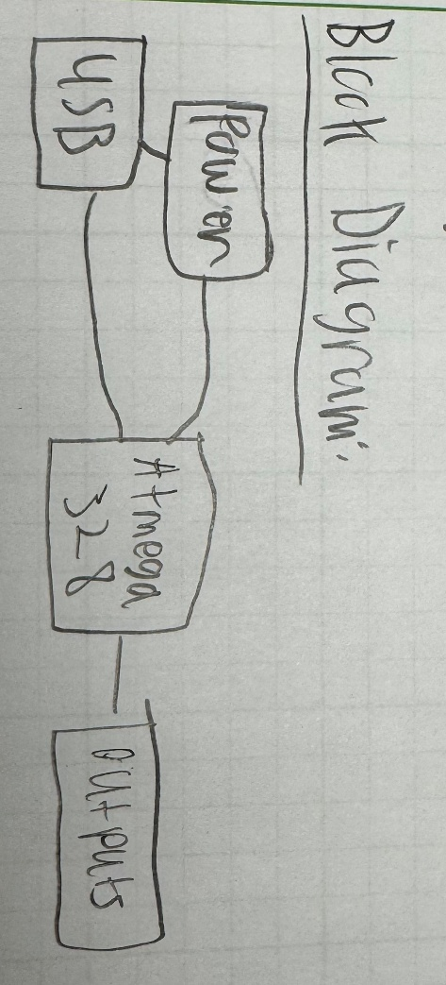
Fig. 1: Block Diagram for Board 3

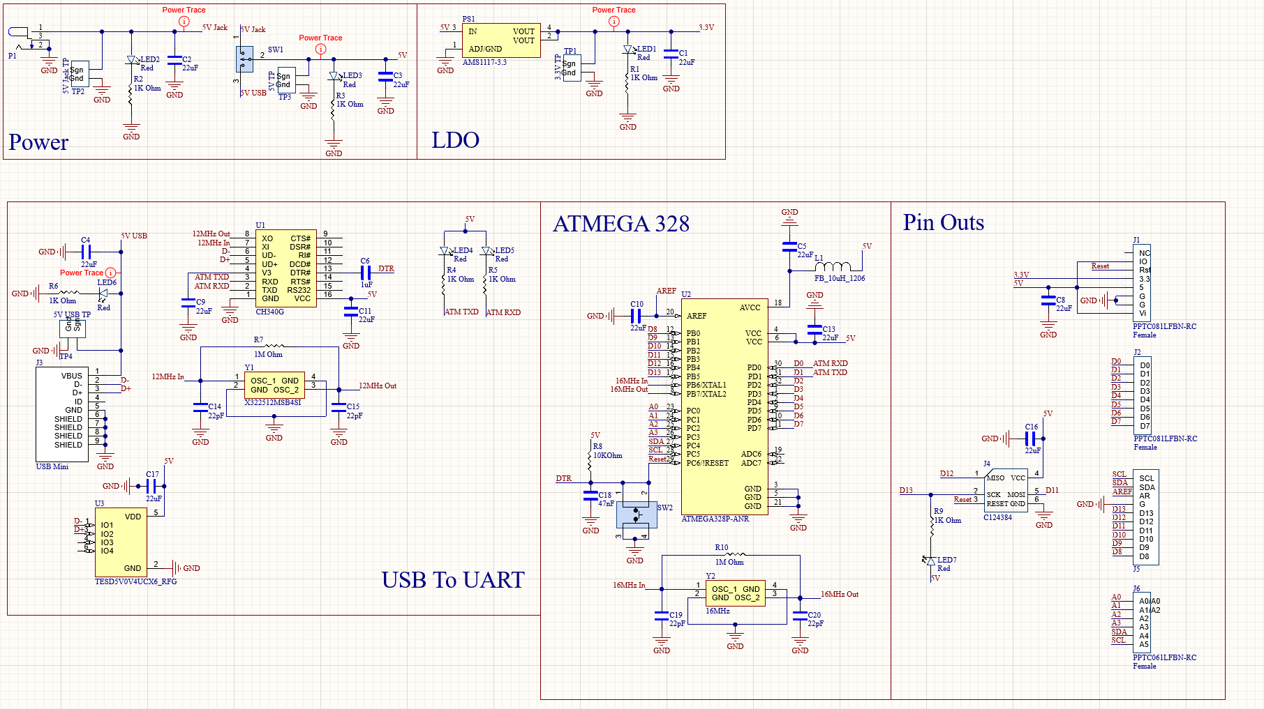
Fig. 2: Schematic for Board 3
When I was designing the PCB itself, I wanted to give myself as much room as possible. There are a lot of components in this board, but there is also a lot routing that needs to happen for the AtMega and the USB to UART. To me, this extra space helped me route and for placement for components. Below is my PCB layout and the board powered up.
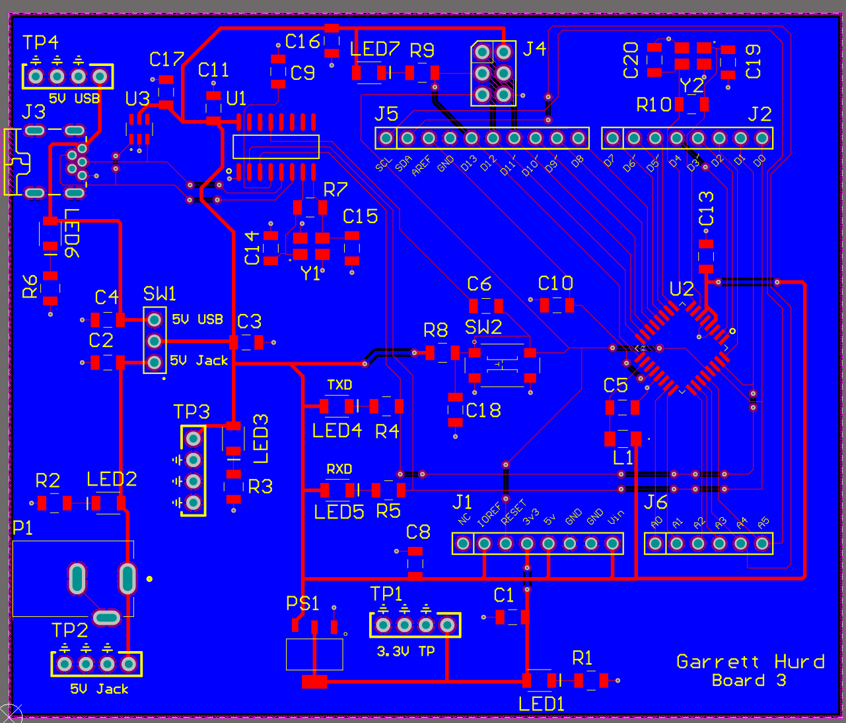
Fig. 3: Layout for Board 3

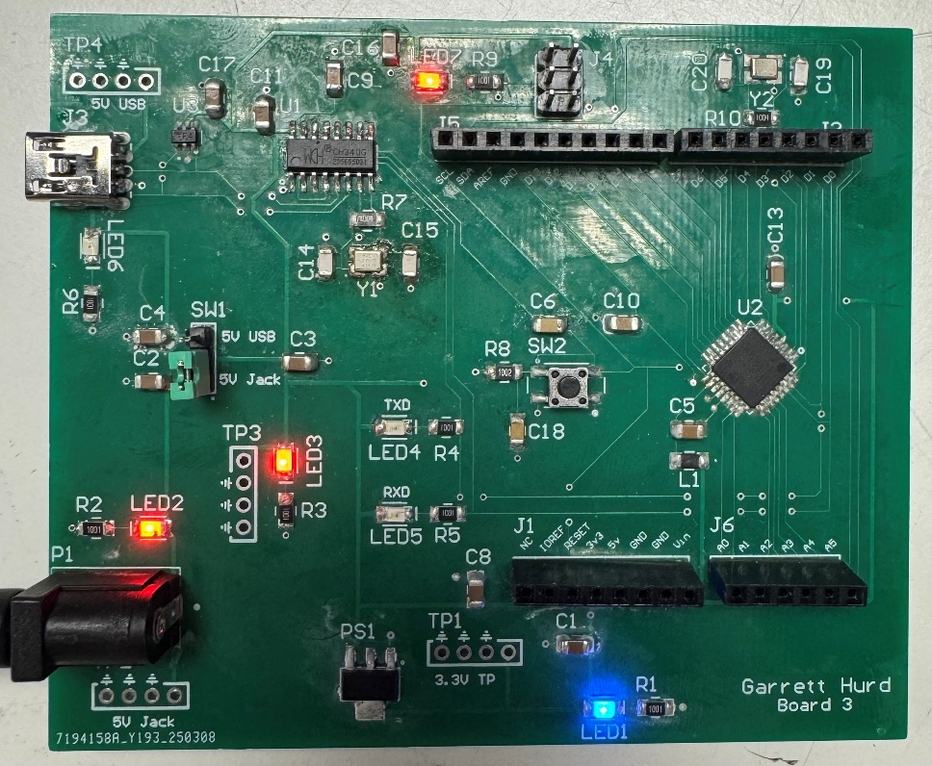
Fig. 4: Powered up Board 3
Figure 4 shows my Golden Arduino powered up, boot loaded and running the code given to us for running the comparison. I didn’t have any issues boot loading my board; however, I did have an issue with communicating with my computer initially. At first, I thought it was an issue with how I routed the USB port to the CH340G, but this wasn’t the issue. I noticed that the 12MHz crystal oscillator wasn’t oscillating at all, so I replaced it but still had the same issue. Finally, I replaced the CH340G chip and connected my board to my computer and then it started working correctly! I was able to upload code to the board, at this point I determined that my board was working correctly and continued with my analysis.

Analysis:
It is now time to compare the switching noise of a commercial Arduino Board to my Golden Arduino. To do this, I will be connecting the provided switching noise shield to the boards and uploading the provided code to each board.
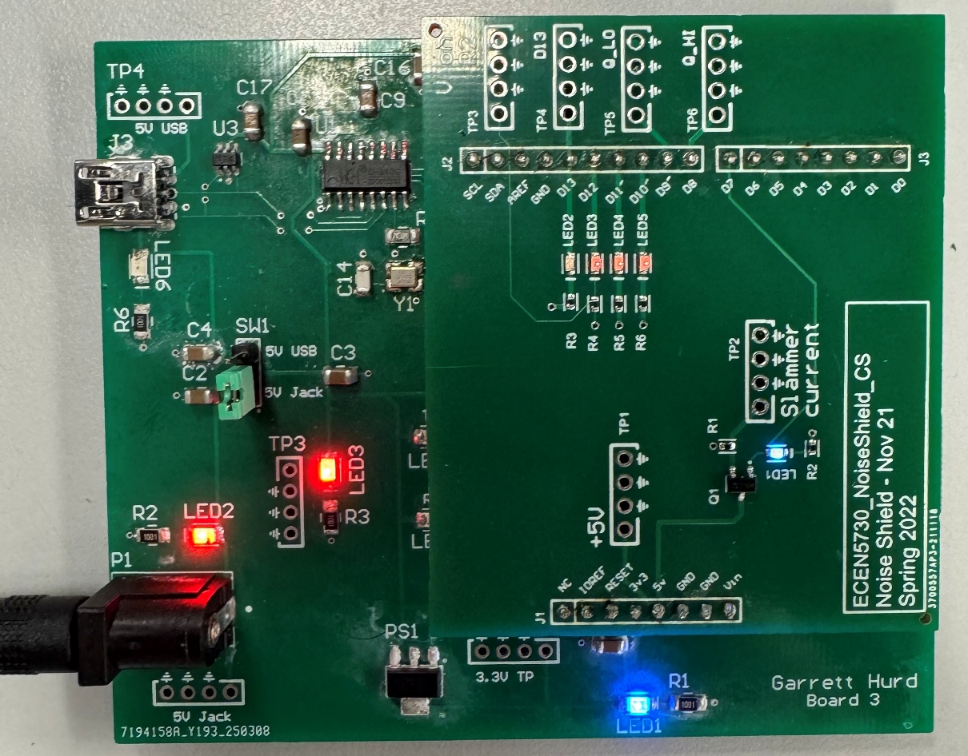
Fig. 5: Golden Arduino with switching noise shield

To determine which board is better, I will compare the switching noise on the quietLOW, quietHIGH and the board power rail when the AtMega switches states using the switching noise shield. The following are the scope shots I took.
Commercial Arduino Scope Shots:
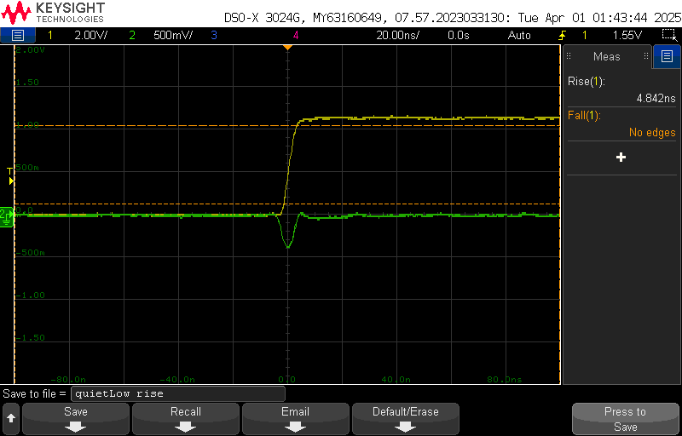
Fig. 6: quietLOW rise time and noise

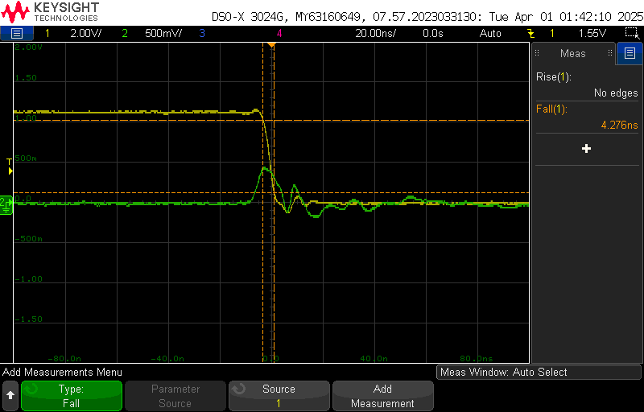
Fig. 7: quietLOW fall time and noise

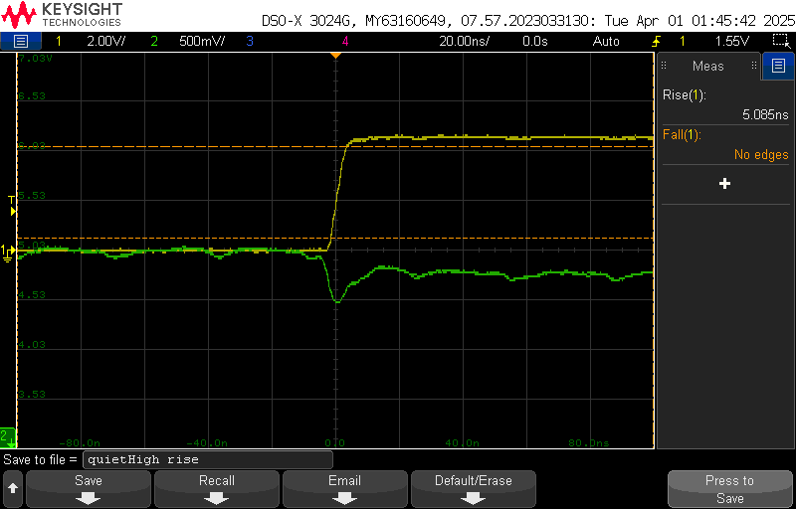
Fig. 8: quietHIGH rise time and noise

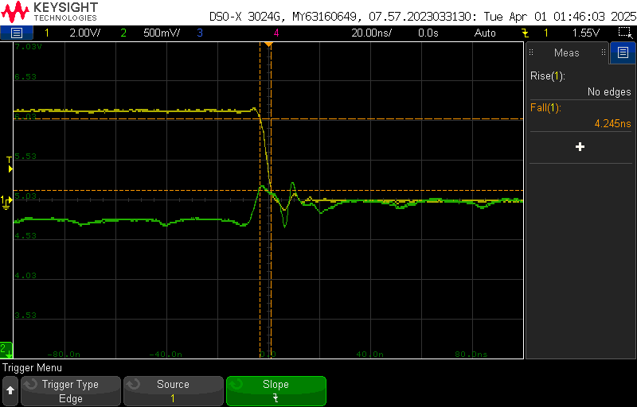
Fig. 9: quietHIGH fall time and noise

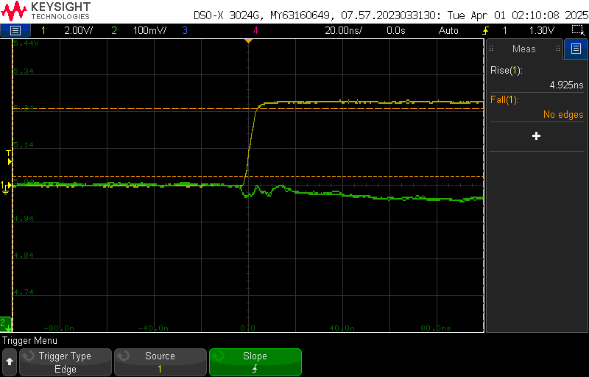
Fig. 10: 5V rail rise time and noise

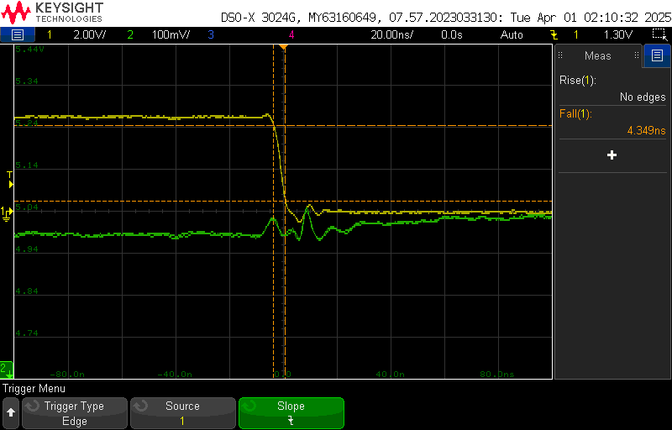
Fig. 11: 5V rail fall time and noise

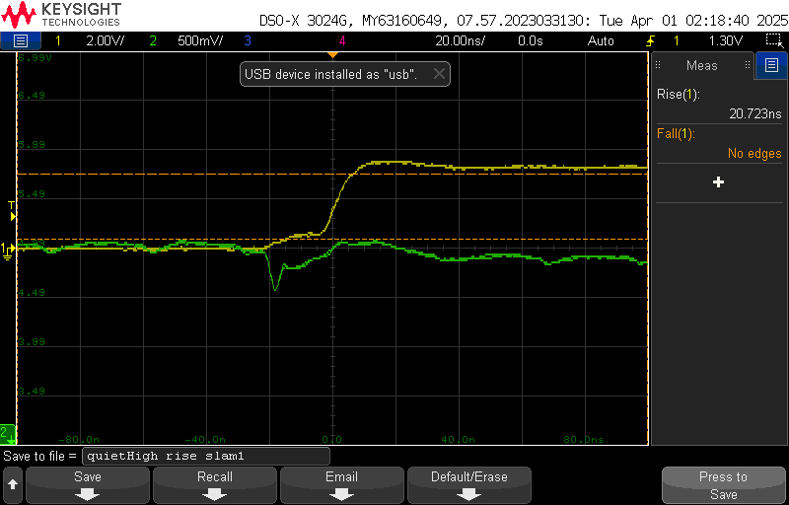
Fig. 12: quietHIGH rise time and noise w/ slammer

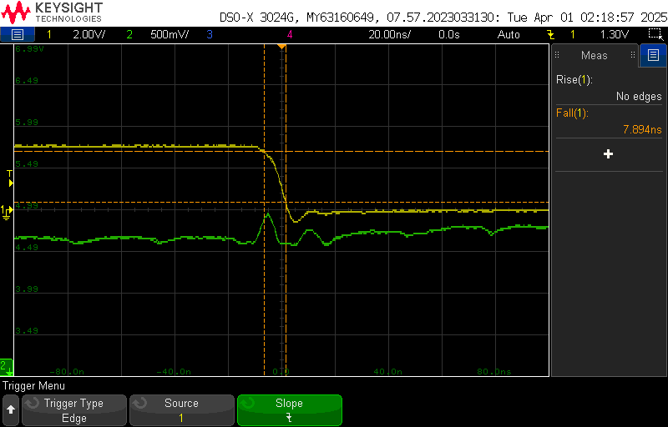
Fig. 13: quietHIGH fall time and noise w/ slammer

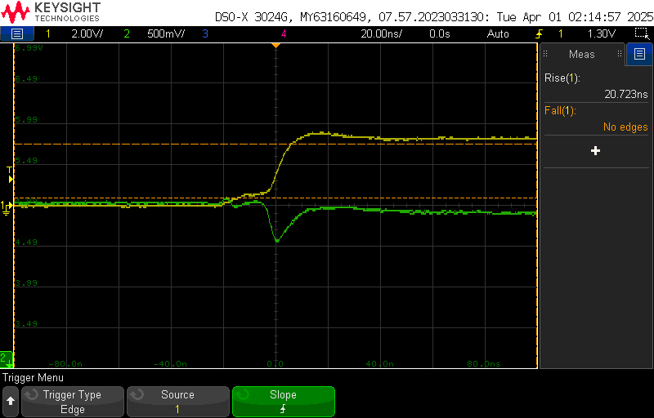
Fig. 14: 5V rail rise time and noise w/ slammer

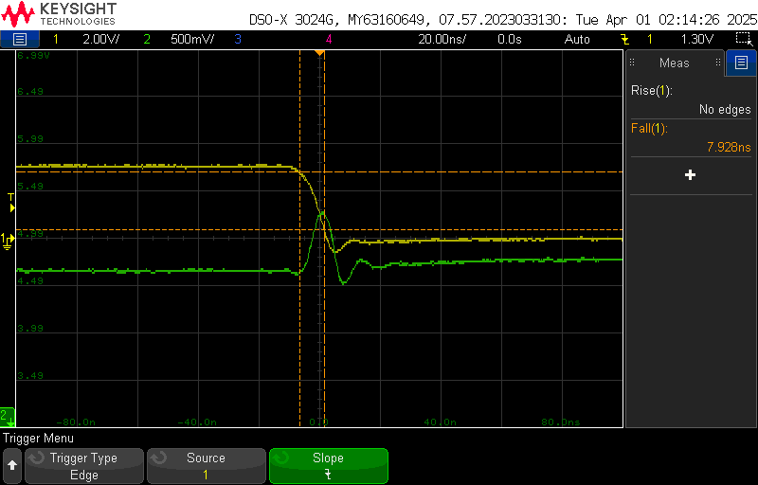
Fig. 15: 5V rail fall time and noise w/ slammer

My Golden Arduino Scope Shots:
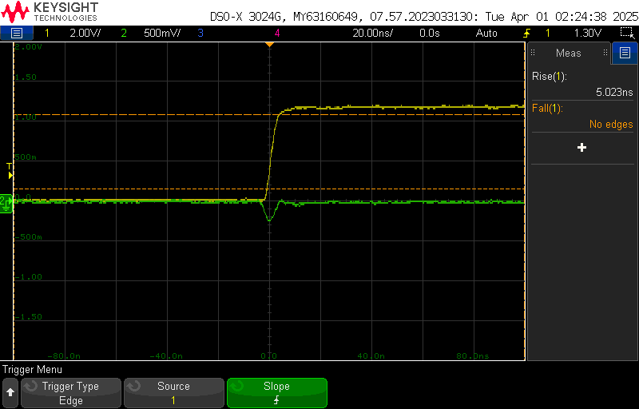
Fig. 16: quietLOW rise time and noise

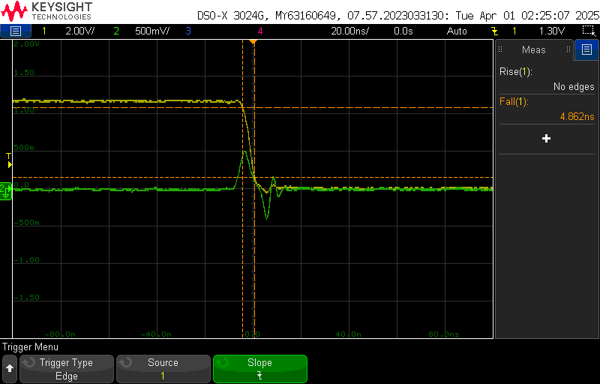
Fig. 17: quietLOW fall time and noise
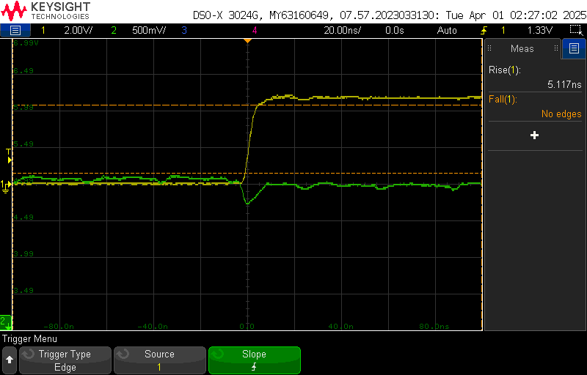
Fig. 18: quietHIGH rise time and noise

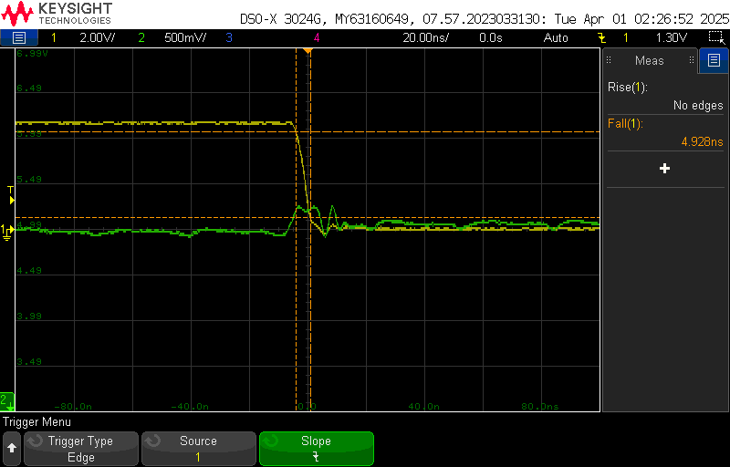
Fig. 19: quietHIGH fall time and noise

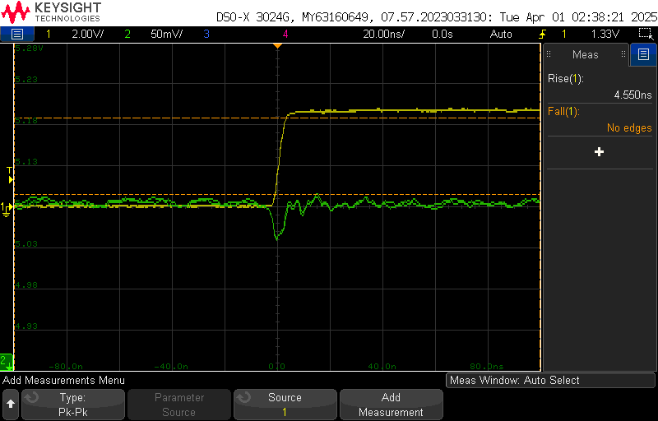
Fig. 20: 5V rail rise time and noise

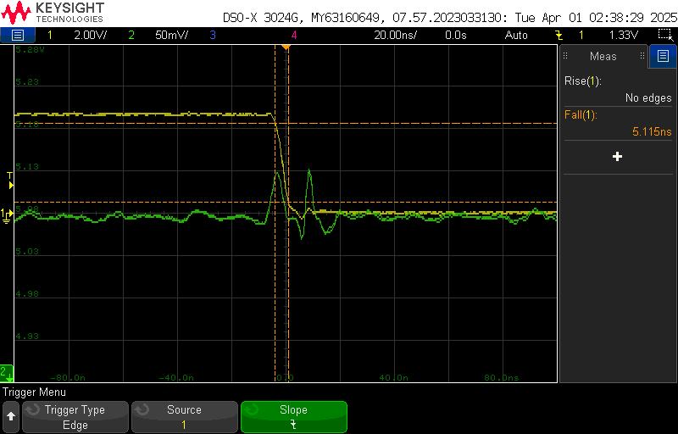
Fig. 21: 5V rail fall time and noise

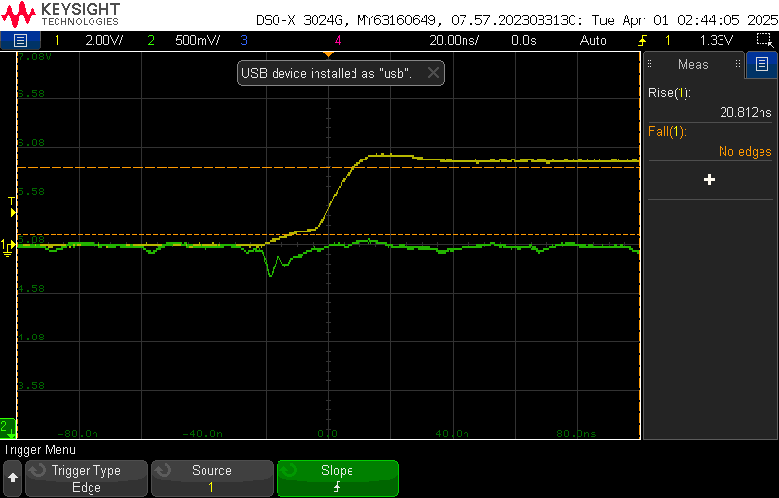
Fig. 22: quietHIGH rise time and noise w/ slammer

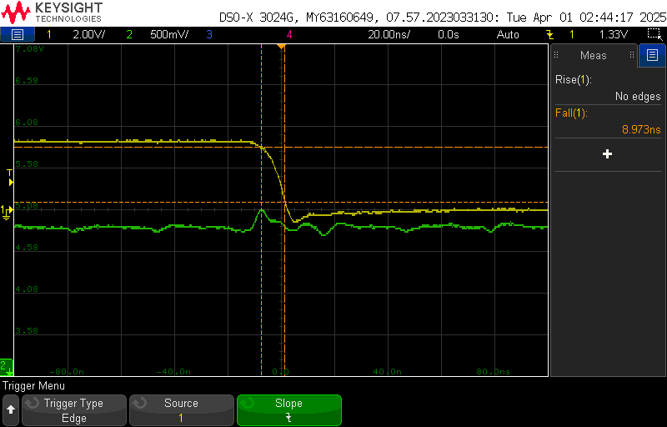
Fig. 23: quietHIGH fall time and noise w/ slammer

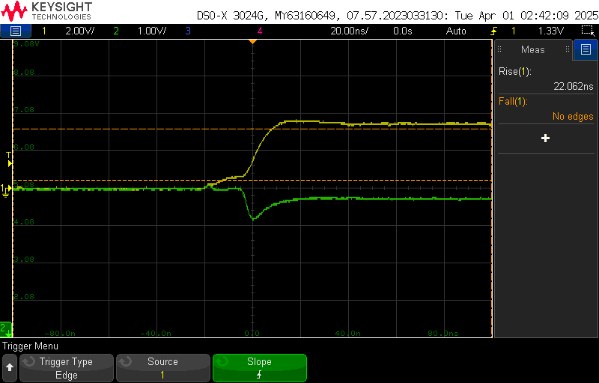
Fig. 24: 5V rail rise time and noise w/ slammer

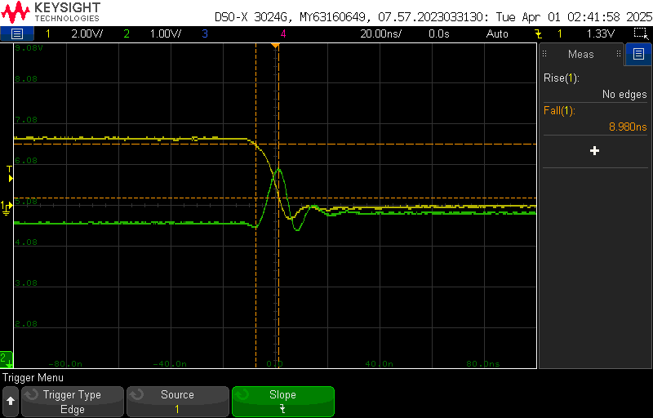
Fig. 25: 5V rail fall time and noise w/ slammer
Rise and Fall times | Commercial Arduino | My Golden Arduino | Comparison
quietLOW Rise | 4.842 ns | 5.023 ns | 1.03x worse
quietLOW Fall | 4.276 ns | 4.862 ns | 1.13x worse
quietHIGH Rise | 5.085 ns | 5.117 ns | 1x worse
quietHIGH Fall | 4.245 ns | 4.928 ns | 1.16x worse
5V Rail Rise | 4.925 ns | 4.550 ns | 0.92x worse
5V Rail Fall | 4.349 ns | 5.115 ns | 1.17x worse
quietHIGH Rise w/ Slammer | 20.723 ns | 20.812 ns | 1x worse
quietHIGH Fall w/ slammer | 7.894 ns | 8.973 ns | 1.13x worse
5V Rail Rise w/ slammer | 20.723 ns | 22.063 ns | 1.1x worse
5V Rail Fall w/ slammer | 7.928 ns | 8.980 ns | 1.13x worse

Conclusion:
Based on the table above, I am sad to report that my Golden Arduino design is slightly worse than a Commercial Arduino in switching times. As for noise, both boards seem to be about the same. This is an unfortunate result since the goal of this board and project was to design a board that would perform better than commercial one. That being said, this is a learning experience, and I’ve identified some improvements I would make to my Golden Arduino in the future.
Firstly, size of the board. As I mentioned at the beginning of the report, I gave myself as much room as I could to place components and route traces. I have never designed such a complex board before so that was one of the main reasons I went with this design decision. Given the results of the analysis, I believe this is one of the main reasons why my board performed poorly.
Secondly, distance between components. Given the extra space I gave myself, I decided to place important components further away from each other compared to a commercial board. In doing this, I believe the extra distance caused more inductance in the traces and that extra inductance led to more noise and poor performance.
Finally, decoupling capacitors. I think I went a bit overboard with adding decoupling capacitors. While it is good practice to add them, I believe that the extra decoupling capacitors I added led to more in rush current happening, leading to more noise and worse performance.
Overall, it was a fun challenge to design, build and power on my first Golden Arduino! I am proud I was able to have a functional custom Arduino that I designed! While the performance is slightly worse than a commercial board, I learned a lot about designing complex boards with a lot of components and traces. In the future, I will work on improving my design process based on the issues I discovered and hope to have an improvement in my board 4 design and eventually my Golden Arduino V2!

